Strategy Plane

What site am I creating?

* This site is for a photographer who is mainly used to using Facebook and Instagram to present their work. But after creating a little following for themselves they have now decided to set up a website to allow potential clients to hire them for certain events such as wedding ect.

Who is the target audience?

* Potential clients who require a photographer for events, weddings, parties, charity events, family portraits ect.
* Potential clients who need to advertise their own business such as wedding planners who want to advertise room layouts and so on.

What are the business goals?

* The photographer want to increase their own following and clientele further as they feel there work is worth money to people who want to hire them, other than just posting photos on social media websites.

Why are we so special?

* There are a lot of photographers out there with their own personal websites which look amazing, but I don’t feel like they attract audience in the correct way and some mobile versions of the sites don’t quite seem to act in the correct way.
* I’m going to create a simple but very effective site that will be responsive and straight to the point.
* When a user visits this site they will be hit simple navigation to roam the site.

Why would the user want this?

* As I said before this photographer already had a following on social media, but they are always getting asked If they have a website to make bookings. What this website will offer is somewhere for their clients to come to book for events weddings and so on.
* This website will provide a portfolio of their work, not just photos on social media but photos and events titled and presented properly.

What content type would be relevant?

* Images need to be big, inviting to make it obvious what they are showcasing.
* Navigation should be simple and easy for all users.
* Text should be short and sweet, straight to the point.

What will make a good user experience?

* Easy and simple navigation.
* Photo’s showcasing their work.
* Contact details for easy bookings
* Information on the photographer (About Me section).
* A portfolio to browse other client’s photos (The work the photographer has done).
* A contact form to leave details.
* A price list for different packages.
* A log in section to view their own page full of their own events images.

|  |  |  |
| --- | --- | --- |
| Opportunity/Problem | Importance | Viability/Feasibility |
| Create an online presence | 5 | 5 |
| Become a blogger | 3 | 1 |
| Showcase work portfolio | 5 | 4 |
| Increase Bookings | 5 | 4 |
| Supply a contact form | 4 | 4 |
| Offer filming as well as photography | 3 | 2 |
|  | 25 |  |

1. Create an online presence
2. Become a blogger
3. 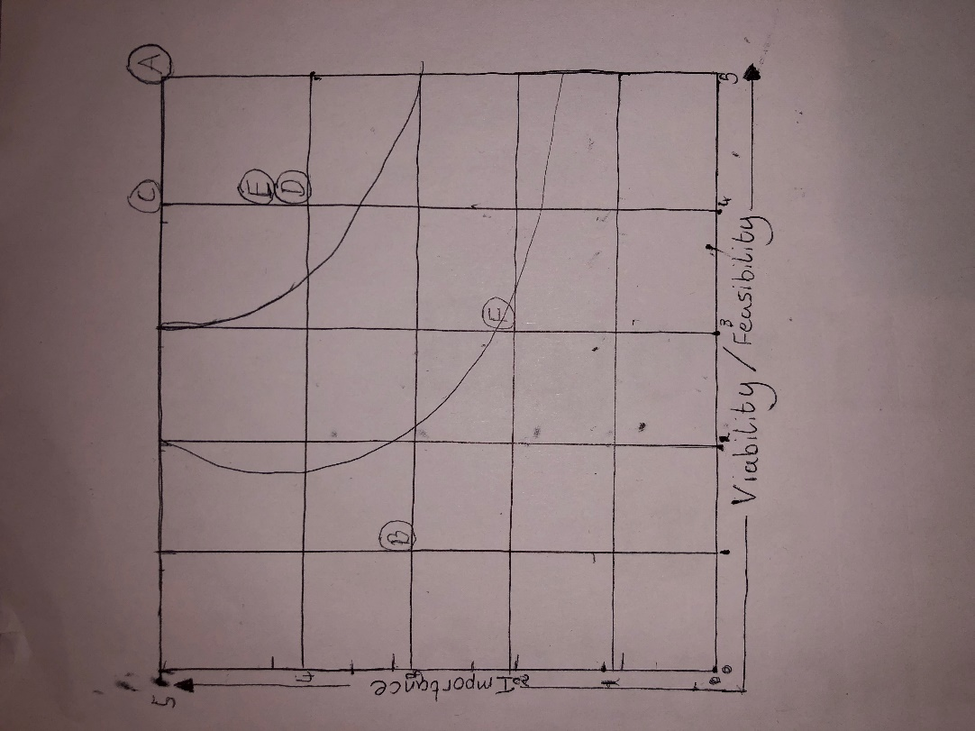Showcase work portfolio
4. Increase Bookings
5. Supply a contact form
6. Offer filming as well as photography

From the table to the right I will be concentrating on :

* A. Creating an online presence
* C. Showcase work portfolio
* D. Increase Bookings
* E. Supply a contact form